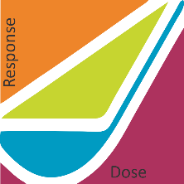

Steve Baker, Ph.D.

Applicability of Radiation-Response Models

to Low Dose Protection Standards

P.O. Box 784

Richland WA 99352

Jose Reyes, Ph.D.

Chief Technology Officer, NuScale Power

1100 Northeast Circle Boulevard Suite 200

Corvallis, OR 97330

USA