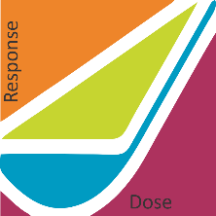

Steven Baker Ph.D., Exhibits Chair

Applicability of Radiation-Response Models

to Low Dose Protection Standards

P.O. Box 784

Richland WA 99352

Lorrie Crum, CH2M Corporate Communications

9191 South Jamaica Street

Englewood, CO 80122-5946

USA