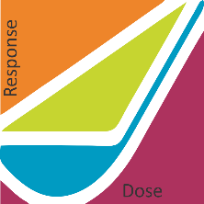

Steve Baker, Ph.D., Exhibits Chair

Applicability of Radiation-Response Models

to Low Dose Protection Standards

P.O. Box 784

Richland WA 99352

Laura Scheele

Idaho National Laboratory

P.O. Box 1625

Idaho Falls, ID 83415

USA